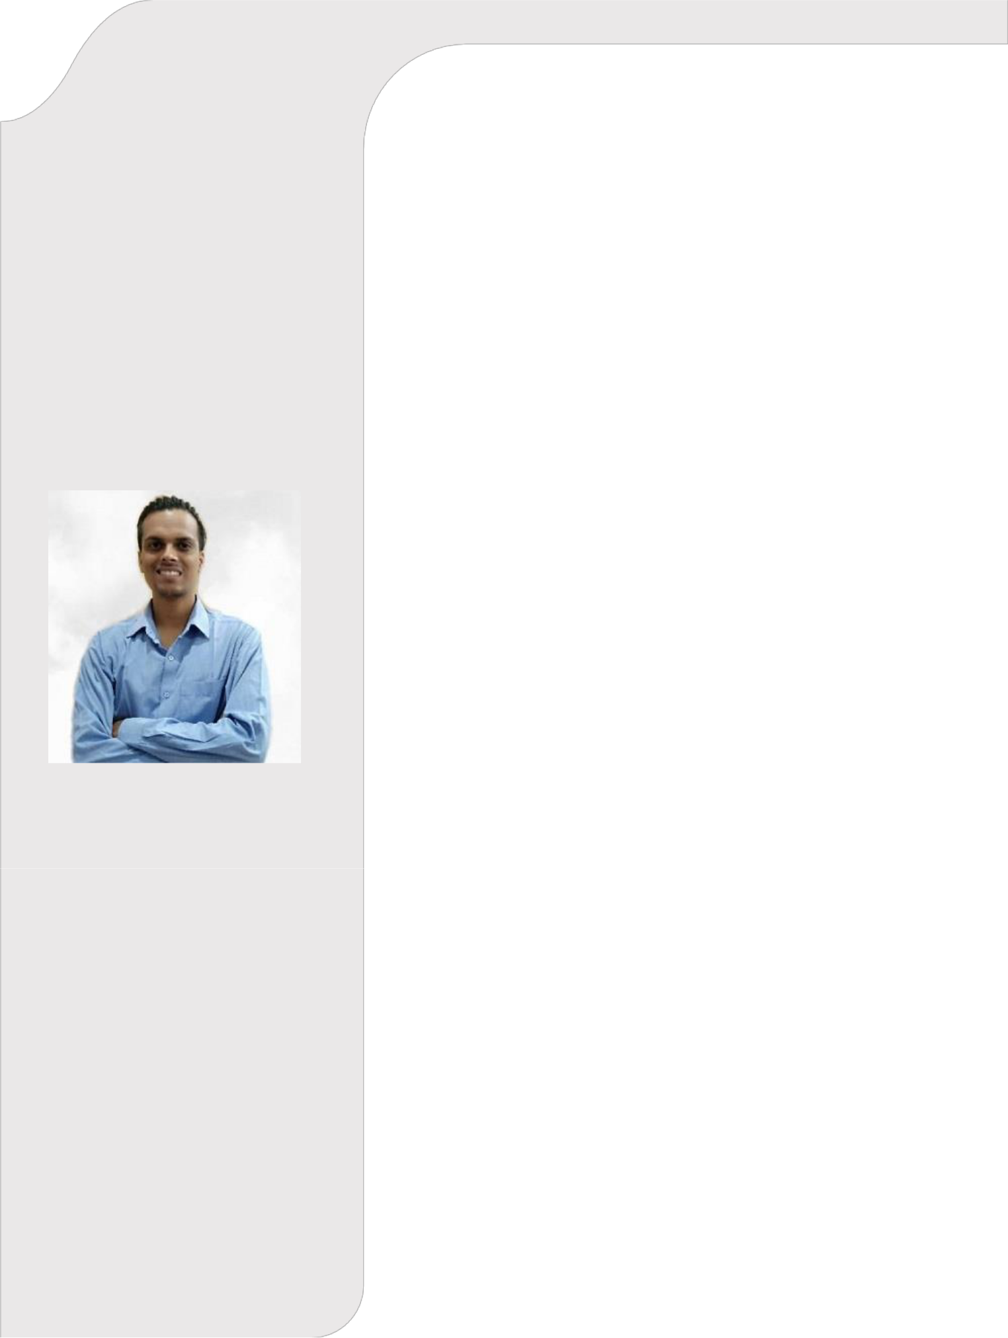

SAURABH

MISHRA

Pursuing B.tech-CSE-Specialization in Software Development from Maharishi Markandeshwar University

PROFILE

Extremely motivated to constantly develop my skills and grow professionally. I am confident in my ability to come up with interesting ideas.

CONTACT

PHONE:

8825149794

EMAIL:

saurabhmishra5887@gmail.com

HOBBIES

- Exploring New Technology

- Organizing Events.

- Online Multiplayer Gaming.

- YOGA.

- Cooking

- Singing

EDUCATION

CLASS  10 | PERCENTAGE  9.2 CGPA | BOARD  CBSE BOARD
12 | 58% | BIHAR BOARD

PROJECTS

Web Projects:

- Created a basis website using HTML, CSS, and JavaScript. In the website there is a petroleum company which is doing pipeline work underground, in the website used API to calculate the distance between two cities. It will calculate the robots required to build pipeline from one city to another.

- Created a website using spring boot, in that done front-end programming in HTML, CSS. Also done back-end programming in java. Provided security in that website.

- Created simple portfolio website using HTML,CSS and some jquery.

- Created the website (using PHP) in Internship and that project is Online Admission System. In that website user can apply for admission, he or she can download the admit card and can see the status of there application, rejected or selected. Admin can upload the admit card, edit the admit card, give access to user, he or she can reject or select an application.

- Desktop applications(using Java):

- Created programmable calculator desktop application which perform scientific calculation up to 25 significant digits.

- Created a desktop application of maze runner done using Iterative approach and using recursive approach.

- Created a project of dictionary, in which user can do certain operations like update, create, delete. Also user can do searching.

- Created a project using JDBC connection in MYSQL. In that project retrieve the data in form of .pdf format.

- Python Projects:

- Created distribution calculator in Microsoft Excel and in python

- Created my own website using django framework in which user can see my projects, he or she can download my projects from database. User can send me emails, recruiters can download my cv and resume .

- Created Multiple progression calculator in Microsoft Excel and in python

- Created prediction interval calculator in Microsoft Excel and in python

- Created mean, median, and mode calculator in Microsoft Excel and in python

- Created simple calculator using python
- Created contact book using dictionaries datastructures in python.

- Student Management System using Python and DBMS. In this project user can check there grades by filling there Name, roll.no, class. User can download there result from database in pdf format.

- Big Data Projects:

- Done the project in map reduce in Hadoop ecosystem. In this project I have been given a set of wordcount and weatherforecast data and then I have applied map reduce on that data and retrived the meaningful answers from that document.

- Done the project in Hive in Hadoop ecosystem. In this project I have done retrieving the given data.

SKILLS

Programming Skills | Tolls Used
Python 3 | PYCHARM
Java | ECLIPSE(JAVA)
PHP | ECLIPSE(PHP)
HTML | BRACKETS
CSS | BRACKETS
JQUERY | BRACKETS
SQL | MYSQL
BIGDATA | HADOOP CLOUDERA

EXTRA – CURRICULAR ACTIVITIES

- Participated in Singing competitions held in college level.
- Participated in Debate competition held in college level.
- Cricket
- Story Telling
- Organiser in college fest
- Cycling
- Gymnastics
- Yoga
- Singing

STRENGTHS

- Leadership
- Team Management
- Passionate to deliver results
- Innovative
- Good Communication
- Energetic

